**AERIAL LIDAR APPLICATIONS IN UAS CONFLICT DETECTION**



# 

# **OPS-812 Practicum**

# **MS Business Analytics Cohort 12 2022**

**Paul Turek | David Rovner | Marc Goulart**

**Anjanee Nikhila | Mingxing He | Aidan Corral**

Table of Contents

Executive Summary 4

1. Introduction **5**

1. Background

1. What is LIDAR? 5-6

2. LIDAR Data Sets 7

3. Drone Autonomy 8

4. NASA TTP Goals 9

5. What’s Happening Now? 10-15

6. Current Challenges 16-17

7. Object Detection Background 18

8. Object Detection Journey 19-20

9. Object Detection Project Terminology 21-24

1. Problem statement 25-26
2. Project Goals 26-27

2. Data Exploration **2****8**

1. USGS Aerial LiDAR 28-29
2. DALES Semantic Segmentation Data Set 30-31
3. Cloud Compare 32

**3.** Approaches **33**

1. Previous Algorithms 33
2. Filtering Algorithms 33-34
3. LiDAR Data Filtering in R 35
4. LiDAR Data Filtering Classification in R 36-37

Table of Contents (continued)

**4.** Results **38**

1. Data Preprocessing 38-39
2. Point Segmentation/K Means Clustering 38
3. Store Obstacles In An Accessible Database 38-39
4. LiDAR Data Filtering: Creating A Threshold 39-43

**5. Future Research Recommendations** **44-46**

**6. Cited Sources 47-48**

# 

# Executive Summary

Advanced obstacle detection systems are the forerunners of UAS. They must be able to recognize obstacles for better performance and safety. Various sensor systems have been employed in the past to identify obstacles. The LIDAR system is one such sensor system that is renowned for its precision in measuring distances. However, the majority of LIDAR (Light Detection and Ranging) systems that are offered for consumer usage are expensive and computationally demanding. This study attempts to describe how a processed and organized aerial LIDAR data is converted to point cloud data and further be used to derive insights in helping achieve potential conflict detection.

In our research, it was discovered that simple clustering algorithms, when paired with the creations of height thresholds along the z dimension of a point cloud, are incredibly effective in partitioning individual obstacles from one another. Our approach was to treat every point above ground-level as if it was a potential obstacle, which meant that a segmentation algorithm between trees, buildings, etc. was not applicable.

We found that the recommended K clusters within a 3 dimensional point cloud array have an inverse relationship with a height threshold as the “floor” of the threshold increases in altitude/ height above ground level.

Furthermore, traditional methods used to find the optimal amount of K clusters within a search parameter is relatively inefficient for areas with sparse vegetation/infrastructure that is located above a certain threshold, because increasing K artificially was found to have beneficial results.

Using linear algebra, a radius was found by calculating the distance from the centroid of each cluster to the point furthest from it within each cluster. These findings were saved to a format that is ready to be uploaded to a geodatabase that we believe can have potential applications in UAV flight planning, particularly in areas that are in the vicinity of designated takeoff and landing sites.

# Introduction

## **Background**

1. **What is LiDAR?**

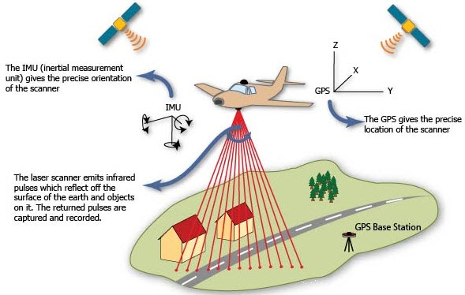

1. LiDAR, also known as LADAR or laser altimetry, is an abbreviation for light detection and ranging. It alludes to a technique for remote sensing that uses powerful, focused laser beams to detect reflection and measure the time it takes for the reflections to be detected by the sensor. This further helps in computing ranges, or distances, to objects. Airplanes and helicopters are the most common and cost-effective platforms for acquiring LiDAR data over broad, continuous areas. Airborne LiDAR data is obtained by mounting a system inside an aircraft and flying over targeted areas. Collision avoidance systems are crucial for enabling autonomous operations for unmanned vehicles of all kinds. These systems take in data from various onboard sensors, as well as data from external sources, and calculate the best maneuvers for the vehicle in order to avoid hitting an obstacle or hazard.

# **LiDAR Data Sets**

1. LiDAR datasets are abundant and updated regularly.

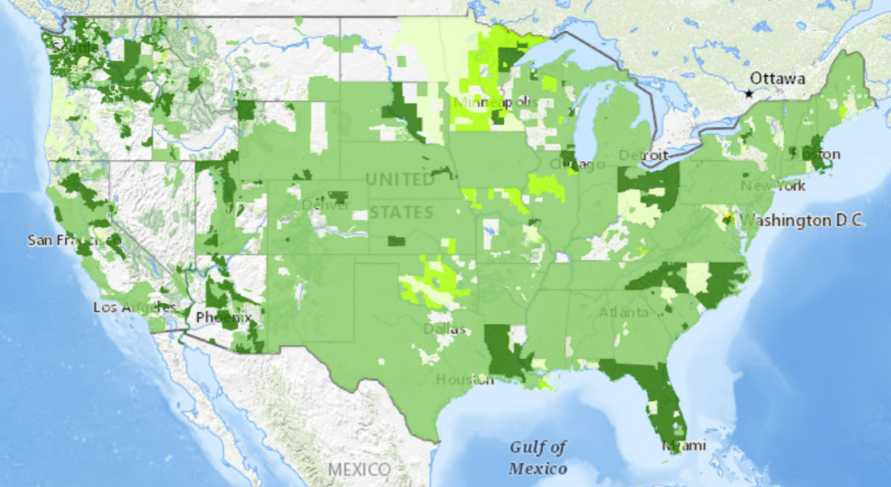

1. Visualization of U.S. topography surveyed by aerial LIDAR (USGS).

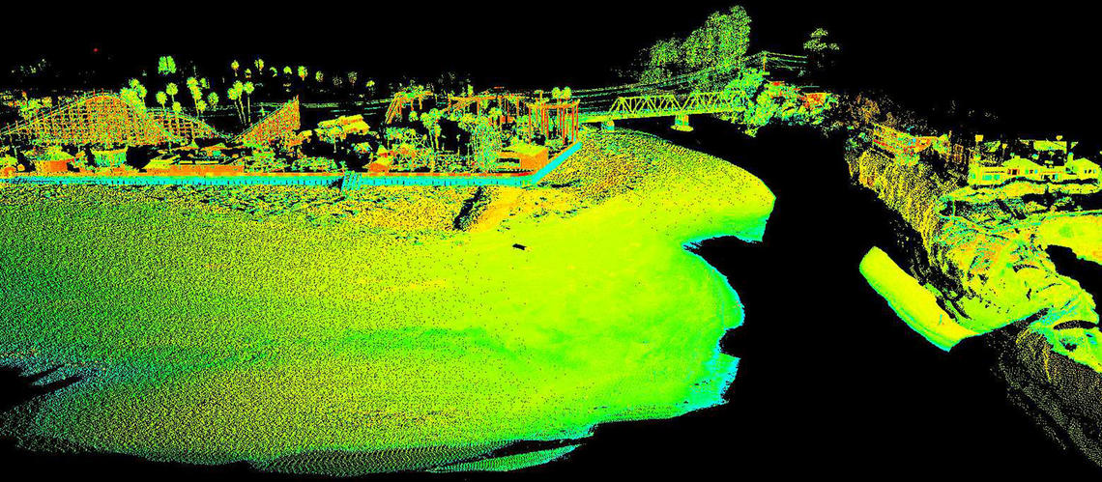

1. Point clouds are sets of points that describe an object or surface. Each point contains an ample amount of data that can be integrated with other data sources or used to create 3D models.
2. **Drone Autonomy**
   1. **Why Integrate LiDAR in Drone Technology?**

In this day and age, drones are becoming more and more integrated in people's daily lives and industries all around the world. As LIDAR is being used constantly, more and more things are being discovered and as technology continues to change, it is really changing the game for industries. For example, this enables drones to use as much information as possible to avoid collisions with static and dynamic obstacles. A crucial aspect are collision avoidance systems that enable autonomous operations for unmanned vehicles of all kinds. These systems take in data from various onboard sensors, as well as data from external sources, and calculate the best maneuvers for the vehicle to make in order to avoid hitting an obstacle or hazard. More advanced systems may use artificial intelligence and computer vision to perform detection and classification of objects picked up by the sensors. Also, areas that are prone to flooding, LiDAR can help improve accurate measurements and help with risk assessment outcomes and planning purposes. (Halsey, A)

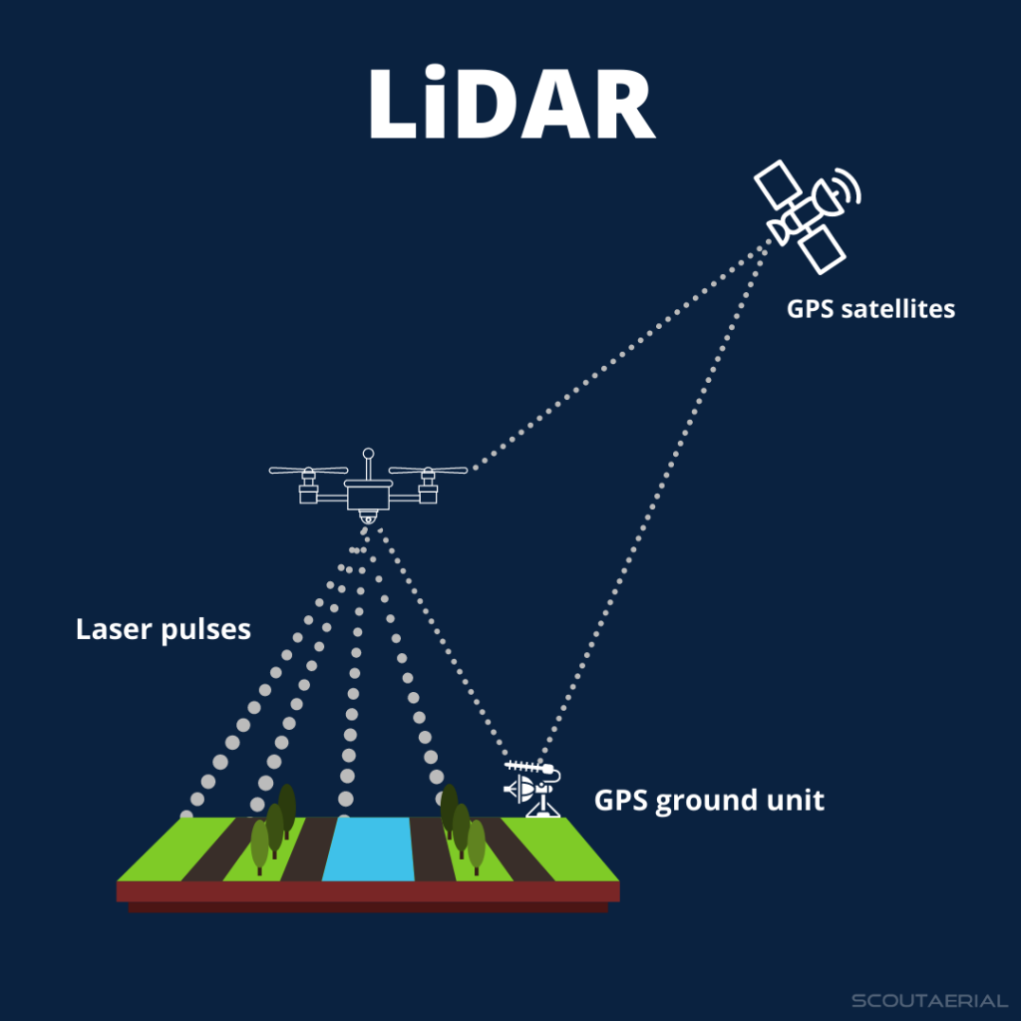

1. **NASA TTP Goals**
   1. **Task**
      1. Use available datasets captured from to increase the capabilities of object detection and avoidance systems.
   2. **Why?**
      1. Commercial drones are becoming increasingly more popular.
      2. These drones are relatively small and the hardware that is onboard the craft must be sparse to minimize weight.
   3. **How?**
      1. Using publicly available LiDAR datasets, create a geodatabase of tall obstacles in urban environments that are hazardous to drones and other aerial vehicles flying at low altitudes.
      2. Minimize the size of the obstacle database so that it can be stored onboard drones, depending on the flight path.

**5. What’s Happening Now?**

At present, the UVAs industry is booming and making continuous improvements. Its application in various industries is becoming more and more extensive. We found UVAS have been used in large areas such as express transportation, aerial photography, plant protection, micro selfie, express delivery, disaster relief and rescue, news reporting, powerline inspections, forest fire prevention, etc.

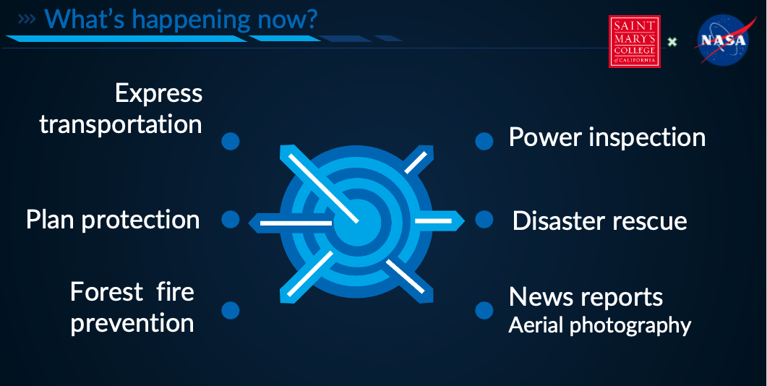

We did a lot of background research and picked out a few cases which stuck out. The following cases showcase what the market looks like:

1. **DODO Pizza**



Eight years ago, Dodo pizza launched their drone delivery service. Due to the weather in Russia, there was a niche for this aerial delivery market. Drone delivery happens to travel faster, cost less, and fits the local customer needs. Now, Dodo Pizza’s sales have increased exponentially. Domino's Pizza in New Zealand began working with Sky Drop on commercial drone delivery. Pizza delivery trials were projected to start in 2022.

1. **Commercial Drone Deliveries are Expected To Increase**

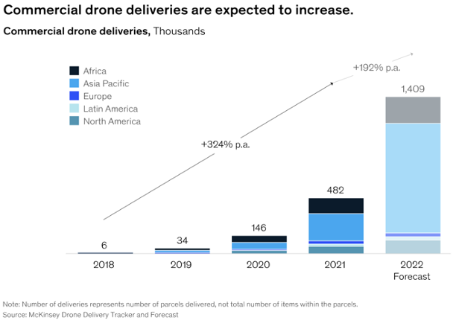

According to the McKinsey Drone Delivery tracker and forecast, the industry is really booming. As of early 2022, they estimate more than 2,000 drone deliveries are occurring each day worldwide. The growth rate is accelerating every week. As the report mentioned, they conducted a survey over

4,500 people across six countries and found most viewed drone delivery in a highly favorable light. Nearly 60 percent of respondents said they would use a drone delivery service today if it were available in their area. Non-contact delivery has become the norm in the COVID-19 era and a new need for the whole world. Using drones is the right fit. They are capable of doing that part of the job. We have seen in the last few years a dramatic change in the drone industry. COVID-19 absolutely gave this industry a huge push.

1. **Zipline**

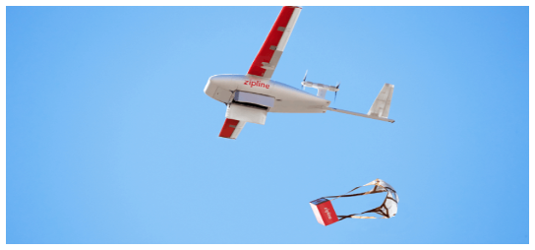

Related to how COVID-19 helped the drone industry, Zipline has helped Pfizer deliver Covid vaccines

and other personal protection equipment to countries which have logistics limitations. Zipline was founded to create the first logistics system that serves all humans equally. For example, in 2020 Zipline protected Ghana’s election with its autonomous delivery network. Medical supply chains are evolving and becoming faster, more flexible, more resilient, and they are turning to on-demand systems. In December 2020, Ghana faced a huge challenge of distributing personal protective equipment during its election within 48 hours. Zipline’s on-demand delivery was able to provide delivery more efficiently with a faster, cheaper and more flexible solution. More than 220,000 COVID-19 vaccine doses from multiple manufacturers had been successfully distributed across Ghana by Zipline. Zipline helped lower the transportation/distribution cost by 40%. As of December 8, 2022, Zipline has served 25 million customers, helped deliver 4,480,991 products, completed 465,775 commercial deliveries, and their drones flew 33,032,715 miles.

1. **A2Z Drone Delivery Winch**

On the Brown University campus, Aaron Zhang made his first drone delivery of cookies in October 2022. Aaron Zhang’s group goal is to make A2Z (drone name) delivery packages drop to your doorstep.

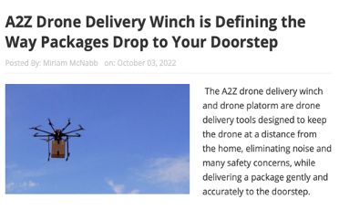

1. **Amazon**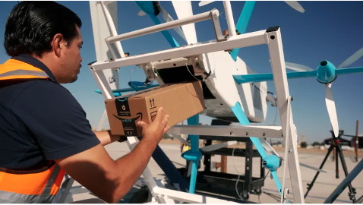

Amazon has continued testing their drone - Prime Air since 2013. On Nov.12, 2022 CNBC News reported Amazon’s Hendrickson gave CNBC a first look at the MK27-2 drone. Hendrickson stated Amazon will start making deliveries in Lockeford, California, and College Station, Texas by the end of 2022. Amazon also announced the next model, the MK30, will launch in 2024.

**6. Current Challenges**

Drones have the potential to reduce transportation time. Drones have become more popular in recent years because it reduces transportation related costs; however, the drones have their own challenge.

1. **Amazon Delivery Drone Crash**

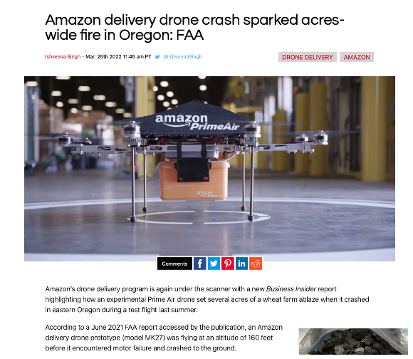

The first example is an Amazon delivery drone’s motor failed causing it to crash and start a wildland fire in Oregon.

1. **Wing Drone Delivery Crash Knocks Out Power For Thousands**

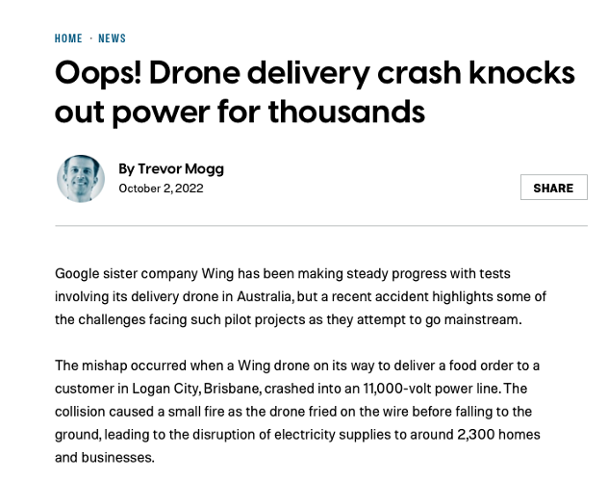

The second example is Google's sister company, Wing, had a drone crash knocking out power in Australia. It caused a small wildland fire causing about 2,300 homes and businesses to lose power.

With the advancement of low-altitude airspace reform, the comprehensive airspace environment is more complex with a higher uncertainty. This results in a geometric increase in the probability of collisions with obstacles during the flight of UAVS. Therefore, the detection method of drones and UAV flight to avoid obstacles is very important.

**7. Object Detection Background**

1. **What is object-detection?**
   1. A software that identifies and locates objects within an image or video.
2. **Uses?**

Image annotation, vehicle counting, activity recognition, face detection, face recognition, video object co-segmentation.

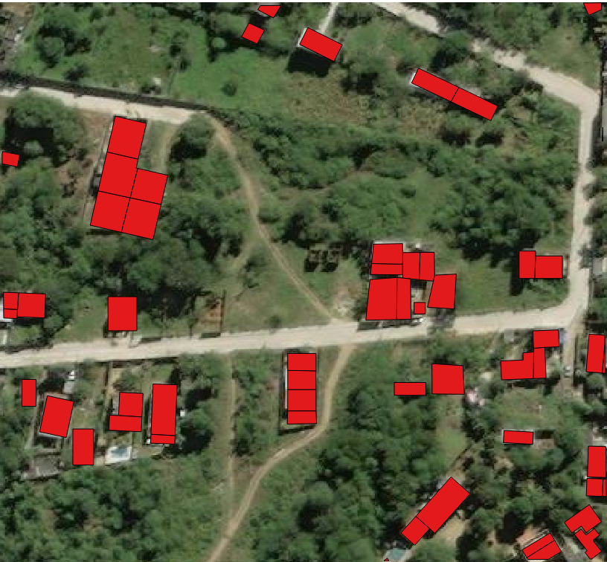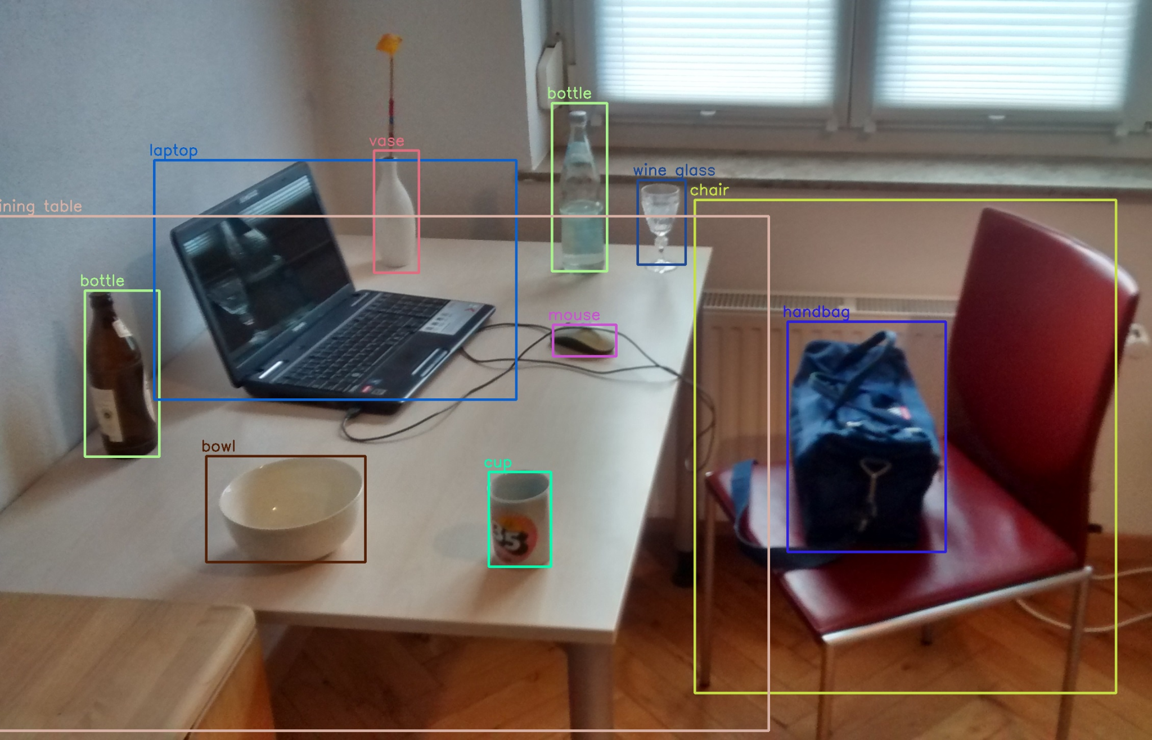

**8. Object Detection Journey**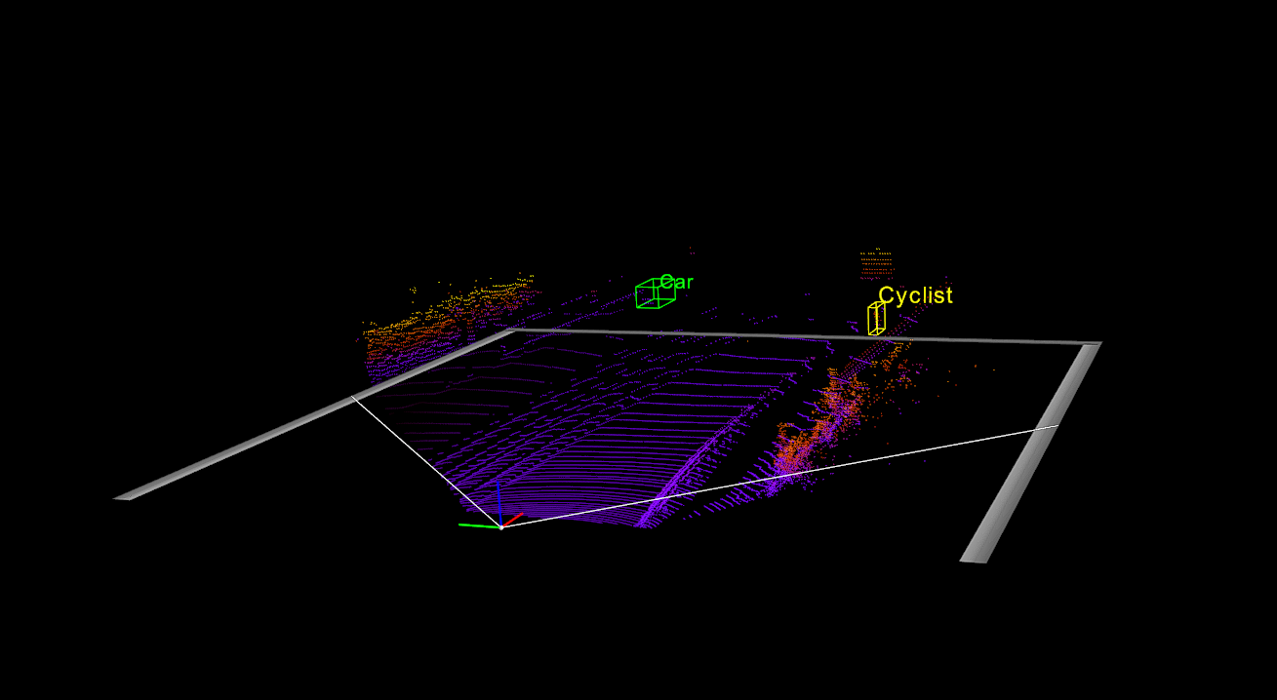

1. **What does the process look like?**
2. Object detection algorithms are evolving at an extremely quick rate. If we take a closer look at the technology we use on a daily basis, we will recognize that object detection is actually just starting to become mainstream. Different technologies such as safety and security systems, self-driving cars, phone cameras, and even robots that deliver your Uber Eats order to your door all use this machine learning software that learns and becomes more efficient over time from past failures and recurring tendencies in the data collected. This technology is highly used and highly powerful, and yet surprisingly accessible to the public. For instance, our group was able to use this technology as a part of our object detection algorithm development, however, due to the time it would take to run VM instances to get the machine to run efficiently, we were unable to continue with this method. Instead, this made great opportunity for our next decision. Our group decided to use updated geographical LIDAR datasets. At this point in our journey, we realized the immense merging possibilities between LIDAR data and obstacle detection algorithms. Our group then attacked the new approach of downloading 3D geographical LIDAR images, importing them into ARCGIS Pro, a geographical reading software system, and transformed the image from a 3D geographic image to a floating 3D point cloud image using the digital elevation model. At this point, we rasterized the point cloud to a threshold of 30 feet and above in order to red flag the areas that the drone is not permitted to fly into or above. After some data cleaning in R Studio, the data is processed through the CSF pipeline to determine ground points & base elevation. K means clustering is to automate finding the optimal amount of clusters within a .las dataset. The very last step is to take the available .csv file with implemented obstacle data and store these obstacles to an accessible database.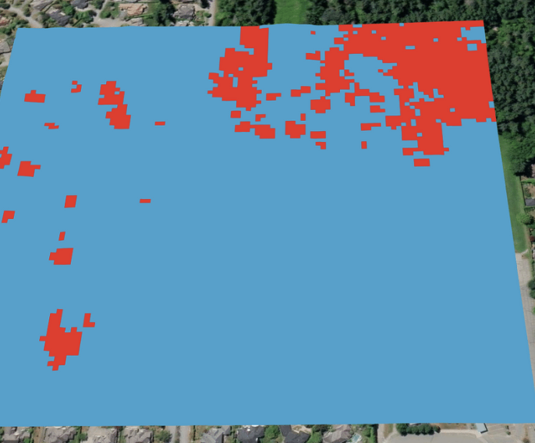

**9. Object Detection Project Terminology**

1. **What is a Point Cloud?**
2. A point cloud is essentially a huge collection of tiny individual points plotted in 3D space. It’s made up of a multitude of points captured using a 3D laser scanner. If you’re scanning a building, for example, each virtual point would represent a real point on the wall, window, stairway, metalwork or any surface the laser beam comes into contact with.
3. The scanner automatically combines the vertical and horizontal angles created by the laser beam to calculate a 3D X, Y, Z coordinate position for each point to produce a set of 3D coordinate measurements which often includes its color value stored in RGB( Red, Green, and Blue). These details can then be transformed into a digital 3D model that gives you an accurate detailed picture.

**b. Digital Elevation Model (DEM) The Intense Details of a Point Cloud**

1. Digital Elevation Model (DEM) is the digital representation of the land surface elevation with respect to any reference datum. DEM is frequently used to refer to any digital representation of a topographic surface. DEM is the simplest form of digital representation of topography.

DEMs are used to determine terrain attributes such as elevation at any point, slope and aspect. Terrain features like drainage basins and channel networks can also be identified from the DEMs. DEMs are widely used in hydrologic and geologic analyses, hazard monitoring, natural resources exploration, agricultural management etc.

DEMs are commonly built using data collected using remote sensing techniques, but they may also be built from land surveying. DEMs are used often in geographic

information systems, and are the most common basis for digitally produced relief maps.

DEMs are commonly built using data collected using remote sensing techniques, but they may also be built from land surveying. DEMs are used often in geographic information systems, and are the most common basis for digitally produced relief maps.

A DEM is a representation of the bare bare earth topographic surface of the Earth excluding trees, buildings, and any other surface.

Using a DEM raster, we can predict the elevation of areas of non-ground points.

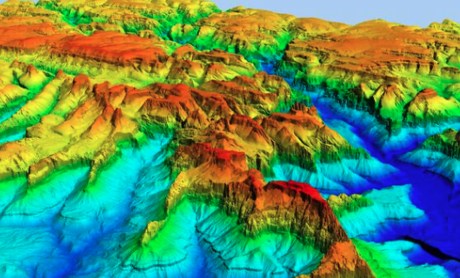

**c. 2D Raster**

1. Rasterization is a simple process of computing the mapping from scene geometry to pixels and does not prescribe a particular way to compute the color of those pixels. Rasterized graphics are often compared with image vectors. While rasterization is typically a process of compiling scan lines or pixels on a bitmap, in contrast, vectors incorporate mathematical functions in order to create images based on geometric shapes, angles and curves.

Rasterization:

1. Mapping from scene geometry to pixels.
2. It refers to the technique of drawing 3D models, or the conversion of 2D rendering primitives such as polygons, line segments, into a rasterized format.
3. Predicts the heights of buildings that are non-ground points.

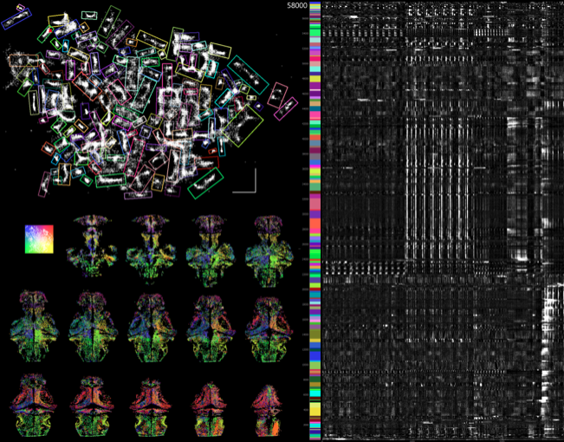

**d. Voxelization**

1. Voxel is an image of a three-dimensional space region limited by given sizes, which has its own nodal point coordinates in an accepted coordinate system, its own form, its own state parameter that indicates its belonging to some modeled object, and has properties of the modeled region.

A voxel represents a value on a [regular grid](https://en.wikipedia.org/wiki/Regular_grid) in [three-dimensional space](https://en.wikipedia.org/wiki/Three-dimensional_space). As with [pixels](https://en.wikipedia.org/wiki/Pixel) in a 2D [bitmap](https://en.wikipedia.org/wiki/Bitmap), voxels themselves do not typically have their position (i.e. [coordinates](https://en.wikipedia.org/wiki/Coordinate)) explicitly encoded with their values. Instead, [rendering](https://en.wikipedia.org/wiki/Rendering_(computer_graphics)) systems infer the position of a voxel based upon its position relative to other voxels (i.e., its position in the [data structure](https://en.wikipedia.org/wiki/Data_structure) that makes up a single [volumetric image](https://en.wikipedia.org/wiki/Volumetric_display)).

Voxels are frequently used in the [visualization](https://en.wikipedia.org/wiki/Data_visualization) and analysis of [medical](https://en.wikipedia.org/wiki/Medical_imaging) and scientific data. It also helps in Predicting the heights of buildings that are non-ground points.

## 

## **b. Problem Statement**

Drones have found enormous applications in different sectors. They have become increasingly popular due to their compact size and comprehensive abilities. Consumers use drones for a variety of needs from photography, agriculture, and construction to public safety and security.

To avoid mid-air collisions, UAVs must be programmed with “sense and avoid” capabilities that match those of manned aircraft. This means that drones must be able to detect a potential collision and maneuver to safety. In the event of collision with an obstacle, falling drones are another serious danger, especially when they are used near large crowds or in highly populated areas.

The sensors are far from perfect. GPS-aided drones can suffer from loss of GPS signals. Localization and mapping algorithms in GPS-denied or intermittent conditions have limitations based on environment texture, reflectivity, types and the quality of sensors used. Algorithms can fail due to sensor limitations and this can lead to drones getting lost or colliding.

The short baselines of stereo cameras [i.e. The distance between cameras] on drones means that they can’t sense depth reliably past about 10 meters which means they need to fly slowly when they expect obstacles like trees, power lines and other obstructions that come their way.

This is where LIDAR data can be extremely useful in areas where it has simply not been considered in the past.LIDAR data is simply underappreciated and underutilized in object detection and avoidance algorithm development. This data is not clunky and does not need an extreme amount of machine power or time to run. Also, LIDAR is constantly updated and is extremely useful when the region of interest for assignment is situated with appropriate ground cover and terrain. In our project, LIDAR data was the core of our project. We built all of our models off of what the database provided. For instance, we were able to turn this data into a point cloud, rasterize it, identify obstacles in the raster, filter the data in R Studio, run a CSF pipeline as well as K-Means clusters as well. LIDAR data is suited with endless possibilities that truly cover all ground terrain data with much less computing power than updating a real time GPS signal on a small drone, while keeping the integrity of the drones shell and core..

## **c. Project Goals**

1. Use available datasets captured from to increase the capabilities of object detection and avoidance systems
2. **Why?**

As technology advances, drones are getting smaller and cheaper. These drones are relatively small, and the hardware that is onboard the craft must be sparse to minimize weight. With the ability to stay airborne for hours at a time, drones are becoming increasingly popular among consumers. They are increasingly popular with consumers and professionals who are looking for innovative solutions for their businesses and homes.

With the rise of the autonomous vehicle, the need for a more effective logistics infrastructure is growing exponentially. With a constant increase in both transportation and logistic costs, there is a real need to utilize new and innovative solutions to improve the efficiency of our current systems. Drones represent one solution that will significantly impact logistics and transportation because they are already capable of providing services to consumers like delivery and package tracking. Businesses across all industries have already taken advantage of drone technology in multiple commercial applications to transform their everyday operations. For example, drones have made a huge impact on the warehouses and inventories

Commercial drones are becoming increasingly more popular in different sectors like:

### 1. Use of Drones in Photography

### 2. Filmmaking

### 3. Use of Drones in Law Enforcement

### 4. Logistics and Transportation

### 5. Architecture and Construction

### 6. Agriculture Industry

7. Real Estate Agents

### 8. Education

1. **How:**

By using publicly available LiDAR datasets and creating a geodatabase of tall obstacles in urban environments that are hazardous to drones and other aerial vehicles flying at low altitudes. Minimize the size of the obstacle database so that it can be stored on onboard drones, depending on the flight path.

# 2. Data Exploration

We initially started with the DALES Data Set then turned our attention to the United States Geological Survey’s (USGS) Data Set. We found through exploring hundreds of .LAZ files most of the USGS data sets were of open terrain and not having much we could work with. As such, we reverted back to the DALES Data Set for our project as there were more objects we needed to meet the parameters we wanted to establish for our project.

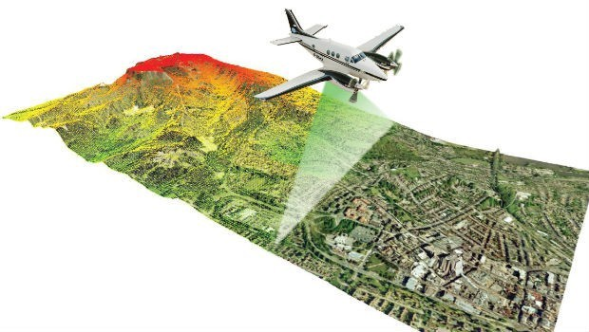

**a. USGS Aerial LiDAR**

USGS Aerial LiDAR is free public data that everyone can access. Aerial laser scanners collect data from a nadir orientation which captures a large scale of land, obstacles, roofs, and tall vegetation. According to sanborn.com, aerial LiDAR (Light Detection and Ranging) is aerial mapping technology that uses calibrated laser returns from the earth’s surface are reflected to an overflying GPS-monitored aircraft equipped with on-board positional and IMU sensors. After post-flight production processes, the acquired LiDAR Map data determines the precise elevation and geospatial location of features on the earth’s surface. With innovations such as multiple intensity returns and increased pulse repetition rates, LiDAR data is an accurate and effective method for creating three-dimensional topographical aerial maps and highly accurate aerial surveys of both surface terrain elements and man-made structures.

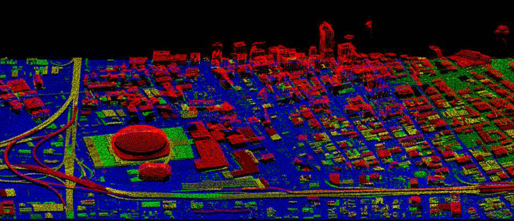

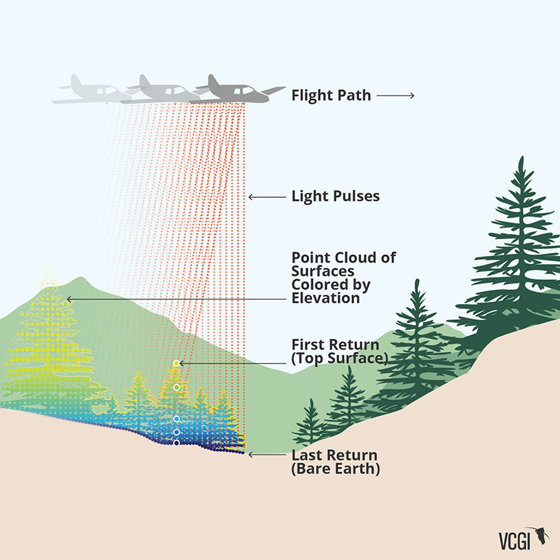

**b. DALES Semantic Segmentation Data Set**

According to Varney, DALES is the most extensive publicly available ALS data set with over 400 times the number of points and six times the resolution of other currently available annotated aerial point cloud data sets. This data set gives a critical number of expert verified hand-labeled points for the evaluation of new 3D deep learning algorithms, helping to expand the focus of current algorithms to aerial data.

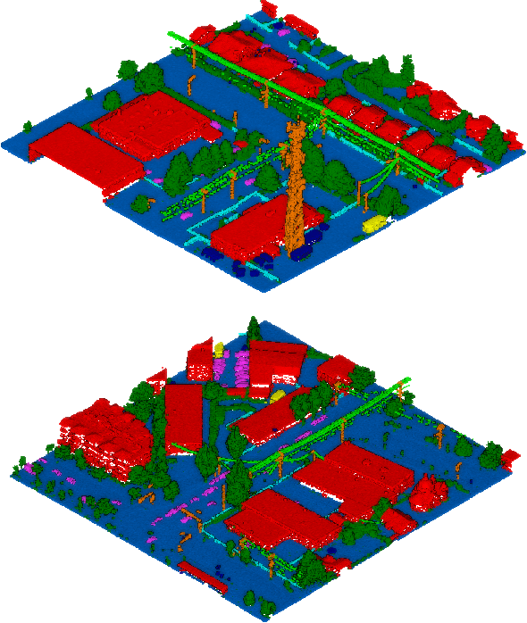

Firstly, we used the DALES (Dayton Annotated Laser Earth Scan) dataset which is a new large-scale aerial LiDAR data set with point cloud segmentation with nearly a half-billion points spanning 10 square kilometers of area (initial data set). The final data set was broken down to forty 0.5 square kilometer tiles. By using this LiDAR data, drones can detect and avoid obstacles in real-time, enabling them to operate safely in complex environments such as forests, urban areas, and disaster zones.

The DALES dataset contains forty scenes of dense, labeled aerial data spanning multiple scene types including urban, suburban, rural, and commercial. This data set is the largest and densest publicly available semantic segmentation data set for aerial LiDAR. The data was hand-labeled by a team of

expert LiDAR technicians into eight categories:

**b. DALES Semantic Segmentation Data Set (continued)**

* Ground (blue).
* Vegetation (dark green).
* Cars (pink).
* Trucks (yellow).
* Poles (orange).
* Power lines (light green).
* Fences (light blue).
* Buildings (red).

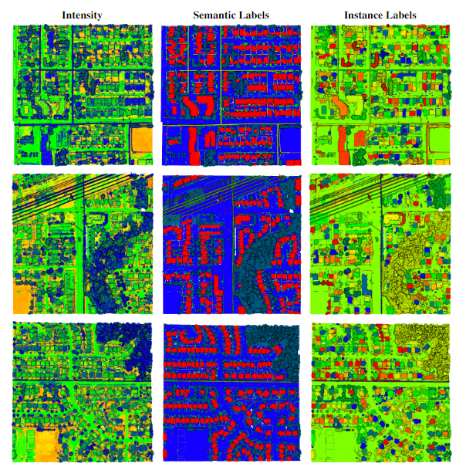

**c. Cloud Compare**

CloudCompare is a 3D point cloud (and triangular mesh) processing software. It has been originally designed to perform comparison between two dense 3D point clouds (such as the ones acquired with a laser scanner) or between a point cloud and a triangular mesh. It relies on a specific octree structure dedicated to this task. Afterwards, it has been extended to a more generic point cloud processing software, including many advanced algorithms (registration, resampling, color/normal/scalar fields handling, statistics computation, sensor management, interactive or automatic segmentation, display enhancement, etc.). Source: https://www.danielgm.net/cc/presentation.html

1. Visualization of an aerial LiDAR dataset of the San Francisco skyline and Bay Bridge with over 11M+ data points in this .LAS file.

Source: USGS Lidar Point Cloud (LPC) ARRA-CA_GoldenGate_2010_001048 2014-08-27 LAS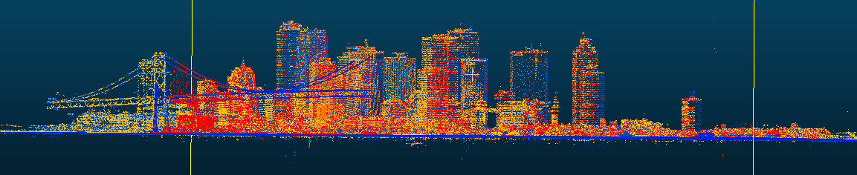

# 3. Approaches

1. **Previous Algorithms**

There were many ground filtering algorithms that have been proposed during the process of this task and most of them were mathematically complex. Three issues that arose was first the performance of these algorithms changes according to the topographic features of the area, second, the filtering results are usually unreliable in complex cityscapes and very steep areas, and third, the models oftentimes fail to effectively model terrain with steep slopes and large variability, due to the fact they are based on the assumption that the terrain is a smooth surface.

1. **Filtering Algorithms**

One of the first steps in working with raw, unclassified LiDAR data is classifying individual points, especially when point clouds can regularly be made of 5-20 million points. Because of the dense nature of LiDAR point clouds, and their ability to pick up noise, like light reflections, a filtering method must be applied to differentiate points.

Separating ground points from non-ground points is an essential step when approaching working with LiDAR point cloud data. By separating ground points from non-ground points, the data is able to be processed into DEMs, DSMs, and other informational derivatives. The process that we chose to separate ground points from non-ground points is the cloth simulation filtering (CSF) algorithm (Zhang

2016). The filtering method proposed, and used in this research paper, is a simple process. Imagine turning a point cloud upside down and then dropping a cloth along the underside of the point cloud, covering the entire underside. By analyzing the interactions between nodes of the cloth and their respective LiDAR points, the shape of the cloth after it is fully settled can be used as a baseline to classify the point cloud into non-ground and ground points within 95% accuracy.

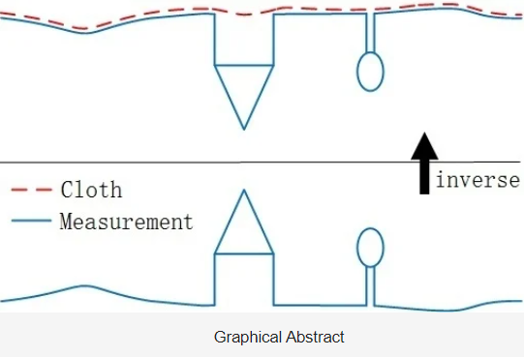

**c. LiDAR Data Filtering in R**

Another way to visualize this simulation is through R Studio. First off, take a point cloud dataset either from Dales or USGS and filter off the ground-level, which the image below represents the filtering after applying the cloth simulation.

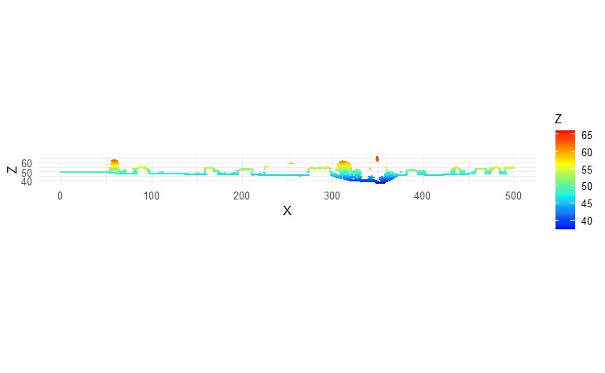

**d. LiDAR Data Filtering Classification in R**

Once we can differentiate ground points from the vegetation and buildings, we can measure the height along the z-axis by subtracting the height of the ground level from the height of the obstacle.

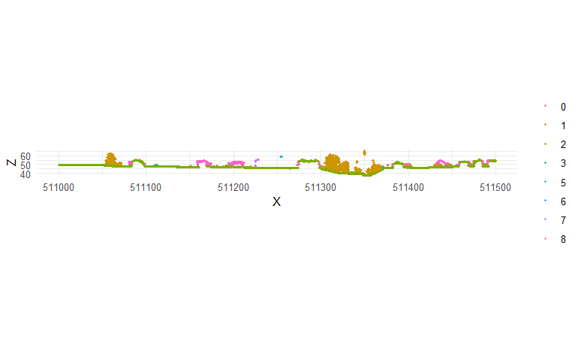

Alternatively, we can view a cross section of just the ground level.



To continue filtering with R Studio, this language was very helpful towards the end of getting the results. The cloth simulation provided tremendous results due to the fact of being able to classify the ground and non-ground objects much more easily. The first image of this represents the outline in green as being the ground level while the other objects in orange and pink are the non-ground objects. Thus, the image below shows how one can see the cross-section between the two and how it is pretty consistent to classify these ground and non-ground points.

Early on in our research, we discovered in ArcGIS that if you rasterize a .las point cloud into 10x10 meter sized grids, and labeled each grid based on the maximum elevation for a point within that 10x10 meter grid, you could have a low-resolution view of a height threshold within ArcGIS for any given point cloud. With this realization, it provided a framework for work going forward. Results and outputs should be easily retrievable in an easy to understand format similar to the information that was seen in ArcGIS.

The 2D grid is a simple, yet elegant solution to finding where a UAV may encounter obstacles while it is flying at low-altitude, with information that is completely derived from point cloud data. We wanted to be able to provide a simple, feasible solution to provide accurate readings as to where there were obstacles at any given low-altitude, as long as there was corresponding LIDAR data.

# 4. Results

**a. Data Preprocessing**

1. CSF pipeline to determine ground points and base elevation.

**b. Point Segmentation/K Means Clustering**

1. Automate finding the optimal amount of clusters within a .LAS dataset.
2. Find the radius of each cluster using the max distance from each cluster centroid.
3. Repeat for different height thresholds.

**c. Store Obstacles In An Accessible Database**

1. Saved results to a .CSV file.

In terms of preprocessing, there was only one large step: the separation of the ground points from the non-ground points. This was easily conquered using the cloth simulation method. By having an algorithm that would automatically separate ground points and non ground points, it saves time from labeling individual points on a point cloud using a GIS front-end like ArcGIS pro or CloudCompare.

While having only two types of classification is not very specific, we do not necessarily need to be granular in our approach, as we treat each and every object above ground level as a potential obstacle for an aerial vehicle. For future applications, it may be necessary to do some data preprocessing to categorize irregular objects such as power lines, due to their inability to be efficiently

clustered along the same parallel.

**d. LiDAR Data Filtering: Creating A Threshold**

In our research, we utilized 3 different height thresholds: 25 feet, 30 feet, and 35 feet. Each threshold was calculated by applying a filter to an array of the point cloud’s x, y, and z coordinates which were extrapolated using python’s “laspy” library. At each of these thresholds, KMeans clustering was performed using Scikit-learn. In terms of tuning hyper parameters, the clustering algorithm was left in its default state due to its surprisingly good results. I believe this can be attributed to the fact that when a height threshold is created above ground level, there already exists separation between points on the x and y dimensions because only a small percentage of the original point cloud is remaining after a filter is applied.

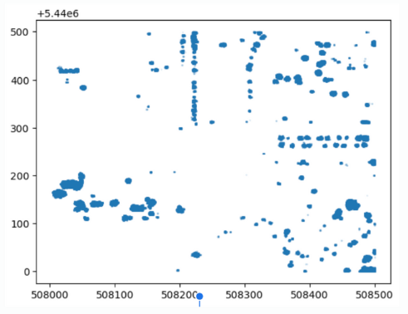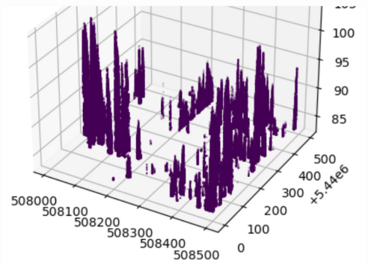

When it comes to what to choose for K, we learned quickly that the traditional elbow method was almost unusable. While the elbow method is useful for finding a K-value where there is a large amount of unstructured data, and relatively low possible categorizations, the point clouds that are derived from an .las are surprisingly structured when a height threshold is applied. Furthermore, we found that if we artificially increased K to beyond what is recommended, we can cluster individual tree tops, towers, large buildings, etc. much cleaner that keeping K low. 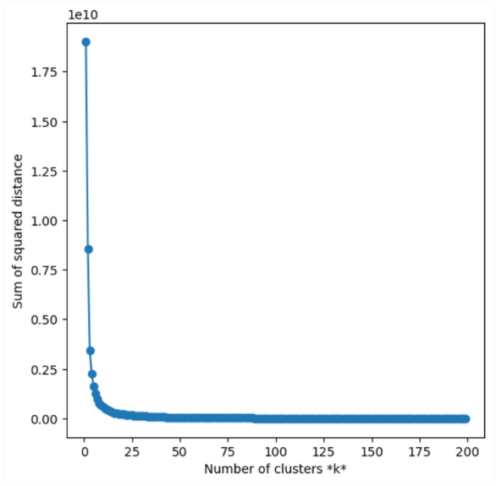

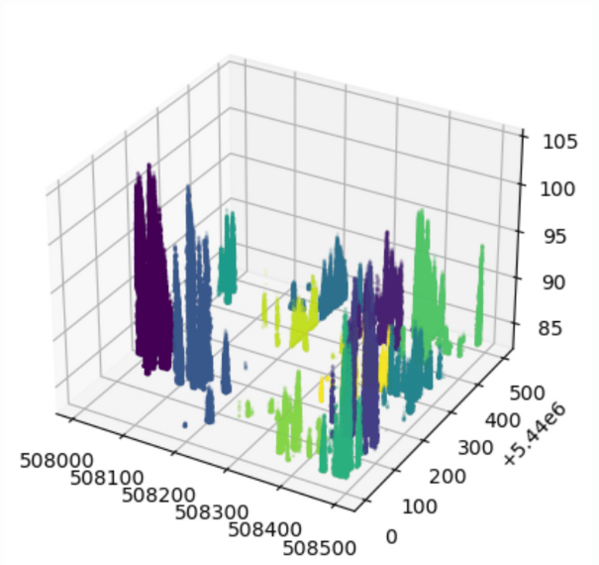

Furthermore, with any KMeans SSE graph, it is typical to give increasing penalties to increasing the K value. This is unfeasible in using KMeans to cluster point clouds because when you increase the K value, the clustering becomes more granular and accurate. Traditional applications of inertia in finding a correct K value can be discarded when clustering point clouds using KMeans.

We found that in the DALES dataset, the most accurate KMeans clusters appeared in height thresholds of 25+ feet, and K being tuned to a number >80. This is because the DALES dataset was retrieved from LIDAR scans of suburban areas within Vancouver, where there is not a lot of heavy foliage. This is an accurate representation of the heavy majority of markets that UAV technology will be first assisting when it comes to commercial package delivery.

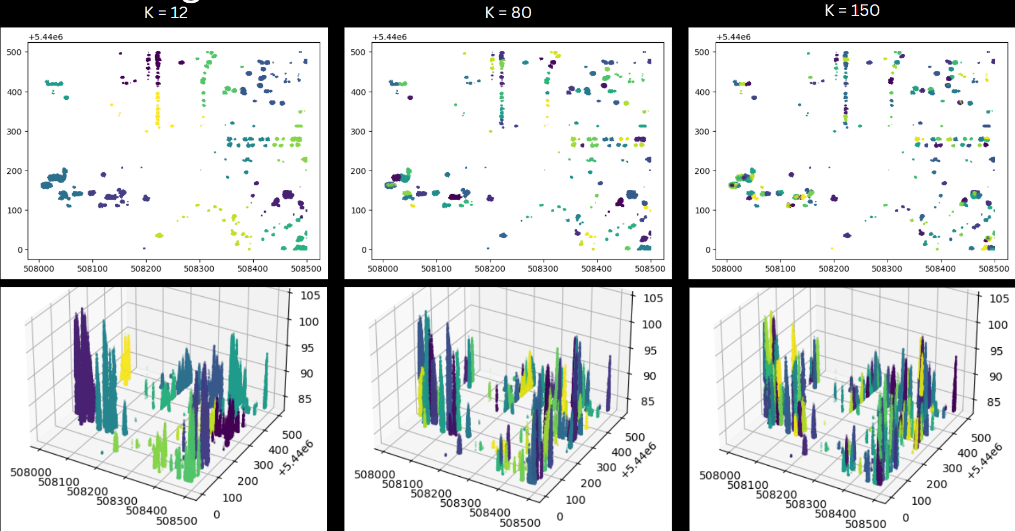

At around K = 80, individual tree tops are much more visible as individual obstacles within our search grid. Parameter tuning for K>50 gave the clustering an appearance of creating artificial tree canopies, where trees that are not close relatively to one another can find themselves being clustered together using KMeans clustering.

As one increases the height threshold of the input array, there is an inverse relationship in K. For point clouds with the largest height threshold that we present, 35 feet, K should ideally be halved of what it was for 30 feet. If we tuned K = 80 at a 30ft. height threshold, K at 35 feet need only be around K = 40. This is because as the height threshold increases, an even more significant amount of the point cloud is not considered for KMeans processing. In any given point cloud, the vast majority of points exist between ground level and 20 ft. above ground level. Using KMeans to cluster a point cloud below 20 ft. of altitude for any given suburban or commercial area would be relatively pointless without considerable hyperparameter tuning. For clustering algorithms below 20 ft, it is recommended to use more advanced GPU enabled deep learning algorithms like PointNet++, which can allocate for angles of surfaces that are derived from relationships between points in the point cloud, and can more accurately discern individual objects that are densely embedded in a 3D space. 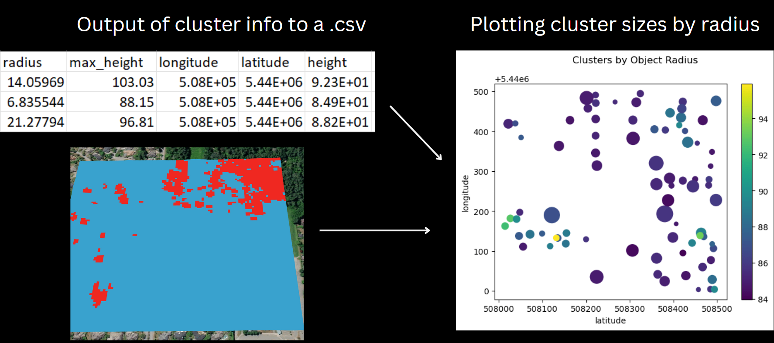

In this project “radius” is used to describe the distance between the centroid in a KMeans cluster, and its point furthest from it within the same cluster using linear algebra. This was found to be a reliable method of building an imaginary spherical boundary around a centroid’s x, y, and z coordinates at any given altitude.

When applying the findings, a flight planner for UAVs can more accurately traverse a suburban landscape by searching for obstacles within our geodatabase. This geodatabase consists of the latitude, longitude, and height of each centroid derived from KMeans clustering at a 20 ft, 30 ft, and 35 ft threshold. This is particularly useful in applications that pertain to takeoff and landing, especially in a designated “dropoff” area, where there would not be many obstacles between ground level and 20ft. above ground level. Using our geodatabase, a UAV flight controller could reference the geospatial location of the centroids along his chosen coordinate plane, and cross reference the radius of each cluster with the proposed flight path. If the UAV flight path intersects the radius of a cluster centroid, the path has to be redetermined. 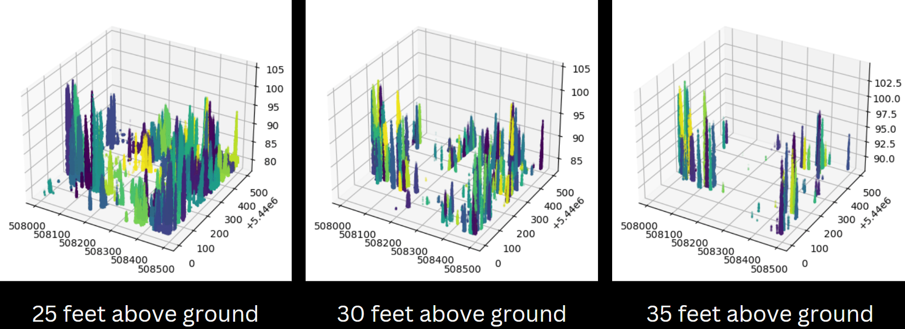

# 5. Future Research Recommendations

1. **Automate the process of creating accurate classification models with the cloth method, and using thresholds to create clusters of tall objects and exporting the data into a SQL database.**
2. While we exported our results into a .csv file, this is not sufficient for a large amount of point cloud data that can come from USGS surveys or otherwise. For this we recommend clustering the point cloud by breaking it up into smaller tiles along the x and y axis for pre-processing, and for suburban areas to keep K between 80 and 150 for a height threshold that is greater than 25 feet. For large swaths of area that was scanned by LIDAR, these results should be saved to a relational geodatabase with SQL- or other technologies more suited to handling large amounts of data.
3. **For irregular shapes, apply more complex methods to fit the shapes of clusters into polygons, and find the vertices of the objects (maybe CNN - pytorch/ CUDA/tensorflow).**
4. For power lines and their respective towers in particular, a GPU integrated deep learning solution may be more applicable to find individual obstacles in a densely populated point cloud by calculating potential surfaces using the angles between the proposed surface and others. I would also be interested in seeing if future researchers

can take into account all objects in the header of a point cloud, such as intensity, and derive their own findings from data outside of the xyz array that we used.

1. **Efficiently downsample the point cloud without loss for small/thin objects like power lines.**
2. For this, I would recommend trying to create a height threshold between two z values where power lines are most likely to be located and applying that to the point cloud array. Power lines should have point data where they are the first return and have a high intensity. Perhaps others going forward can take this information and use it to tune a model that can cluster this information through feature engineering and one-hot encoding. Furthermore, clustering of obstacles like power lines may be more accurate if a point cloud is sliced along these two z values, and clustered with the x and y values as the input array. This may give better results as power lines typically exist parallel to streets, and 2D representation of the point cloud data may let algorithms find relationships between points from power lines more efficiently. In doing so, it is recommended that for classification/clustering purposes, that clustering takes place in a space before the two z values that power lines exist, so that they are not clustered together with other obstacles that are along similar vectors to power lines.
3. **Use voxelization to efficiently loop through point clouds with CNNs, take voxel heights and use for step 2.**
4. Admittedly, voxelization was heavily overlooked in the research that went into this project. I believe that voxelization gives a way to find the most accurate representation

of downsampled LIDAR point cloud data, but it is not without its flaws. It can not easily find voxel relationships between small objects like power lines (power lines are a big problem in unsupervised 3D clustering/classification), but in the long run, it is of my opinion that voxelizing power lines is unimportant because private companies will purposefully choose flight paths where power lines pose no threat (ascending/descending where the lines are located).

1. Voxelization of point clouds allows for raster processing times in computing spatial relationships, and clusters can more easily be found when point clouds are downsampled to voxel space. Furthermore, when it comes to swarming/ creating a drone “superhighway”, one must account for the wake that each individual drone produces. Such physical effects on the environment can be more accurately simulated using voxelization.

# 

# 6. Cited Resources -

Zhang, Wuming, Jianbo Qi, Peng Wan, Hongtao Wang, Donghui Xie, Xiaoyan Wang, and Guangjian Yan. 2016. "An Easy-to-Use Airborne LiDAR Data Filtering Method Based on Cloth Simulation" *Remote Sensing* 8, no. 6: 501. <https://doi.org/10.3390/rs8060501>

Rebecca Borison, This Russian Pizzeria will deliver your pizza by drone, on Jun. 23, 2014

[This Russian Pizzeria Will Deliver Your Pizza By Drone](https://www.businessinsider.com/russian-pizzeria-delivers-pizza-by-drone-2014-6)

Dodo brands Russia, First commercial pizza delivery by drone. They post on youtube 8 years ago.,

[Додо Пицца первая коммерческая доставка пиццы по воздуху | June 21st, 2014](https://www.youtube.com/watch?v=5l22FmvEysA&t=52)

SkyDrop, Domino’s signs deal with Sky Drop to launch next stage of commercial drone delivery in New Zealand, Jan.26,2022tt//www.mckinsey.com/industries/aerospace-and-defense

[Domino's signs deal with SkyDrop to launch next stage of commercial drone delivery in New Zealand](https://www.prnewswire.com/news-releases/dominos-signs-deal-with-skydrop-to-launch-next-stage-of-commercial-drone-delivery-in-new-zealand-301468333.html)

Sarina Carter, Tore Johnston, Stephen Lidel, Robin Riedel, Leonard Tusch, Drone delivery: More lift than you think March 15, 2022

[Drone delivery: More lift than you think | McKinsey & Company](https://www.mckinsey.com/industries/aerospace-and-defense/our-insights/future-air-mobility-blog/drone-delivery-more-lift-than-you-think)

Pfizer, Zipline, Pfizer, and BioNTech Collaboration Paves the way for Automated, One-Demand Delivery of FIRST mRNA COVID-19 Vaccines in Ghana. November 11, 2021

[Zipline, Pfizer and BioNTech Collaboration Paves the Way for Automated, On-Demand Delivery of First mRNA COVID-19 Vaccines in Ghana](https://www.pfizer.com/news/press-release/press-release-detail/zipline-pfizer-and-biontech-collaboration-paves-way)

Zipline, Protecting Ghana’s Election: Instant agility with zipline’s autonomous delivery network Feb 2021

[Protecting ghana’s election: Instant agIlIty WIth ZIplIne’s autonomous DelIvery netWork](https://assets.ctfassets.net/pbn2i2zbvp41/3yrQaMNdJ1u1J2aSEucjzt/4412ea5d12896d15b7eb41a2212d0295/Zipline_Ghana_PPE_Global_Healthcare_Feb-2021.pdf)

CNBC, Katie Tarasov, First look at Amazon’s new delivery drone, slayed to start deliveries this year, Nov.11, 2022

[A first look at Amazon's new delivery drone](https://www.cnbc.com/2022/11/11/a-first-look-at-amazons-new-delivery-drone.html)

Miriam McNabb, A2Z Drone Delivery Winch is Defining the Way Packages Drop to Your Doorstep, October 03, 2022

[A2Z Drone Delivery Winch is Defining the Way Packages Drop to Your Doorstep](https://dronelife.com/2022/10/03/a2z-drone-delivery-winch-is-defining-the-way-packages-drop-to-your-doorstep/)

# Ishveena Singh, Amazon delivery drone crash sparked an acres-wide fire in Oregon: FAA, Mar.25th 2022

# [Amazon delivery drone crash sparked acres-wide fire in Oregon: FAA](https://dronedj.com/2022/03/25/amazon-delivery-drone-crash-oregon/)

Trevor Mogg, Oops! Drone delivery crash knocks out power for thousands Oct 2, 2022

<https://www.digitaltrends.com/news/drone-delivery-crash-knocks-out-power-for-thousands/>

Real-time Track Obstacle Detection from 3D LIDAR Point Cloud, 2021

<https://iopscience.iop.org/article/10.1088/1742-6596/1910/1/012002/pdf>

## A Large-scale Aerial LiDAR Data Set for Point Cloud Segmentation <https://udayton.edu/engineering/research/centers/vision_lab/research/was_data_analysis_and_processing/dale.php>

Halsey, A. (2021, January 25). *How drone based Lidar is changing the game*. Geospatial World. Retrieved December 9, 2022, from https://www.geospatialworld.net/blogs/how-drone-based-lidar-is-hcanging-the-game/

[Nina Varney](https://arxiv.org/search/cs?searchtype=author&query=Varney%2C+N), [Vijayan K. Asari](https://arxiv.org/search/cs?searchtype=author&query=Asari%2C+V+K), [Quinn Graehling](https://arxiv.org/search/cs?searchtype=author&query=Graehling%2C+Q), DALES: A Large-scale Aerial LiDAR Data Set for Semantic Segmentation, Apr 14, 2020, <https://arxiv.org/abs/2004.11985>

# Aerial LiDAR, <https://www.sanborn.com/aerial-lidar/>